Title of the Paper (18pt)
AUTHOR SURNAME, Name¹, AUTHOR SURNAME, Name ², … (Times new roman 12 pt)
¹Institution1, ² Institution2 (Times new roman 12 pt)
presentingauthor@eposta.com.tr (Times new roman 12 pt)

SUMMARY
Times new roman 10
Max. 250 words

PURPOSE
Times new roman 10
Max. 250 words

INTRODUCTION
The importance of the subject, uses of the topic literature survey, etc…
Times new roman 10
1000-2500 words

The cited work will be designated with superscript numbers.
eg: in Çelik’s research¹

EXPERIMENTAL
Material
Times new roman 10
Max. 250 words

Method
Times new roman 10
Max. 250 words

EXPERIMENTAL RESULTS AND DISCUSSIONS
Times new roman 10
500-1000 words
Figures and Tables

Table 1. Comparison of the crystallinity of PP and PET fibres
 | 50⁰C | 70⁰C | 90⁰C
PP
PET
PVC

- AUTHOR SURNAME, Name (ORCID No) (Times new roman 10 pt)
- AUTHOR SURNAME, Name (ORCID No) (Times new roman 10 pt)
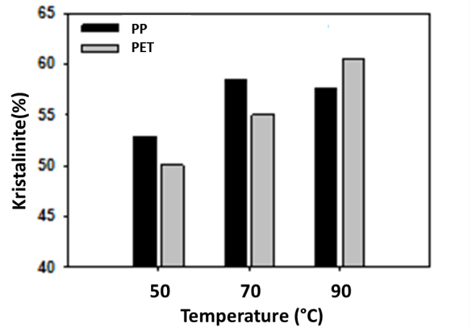
Figure 1. Comparison of the crystallinity of PP and PET fibres
CONCLUSIONS
Times new roman 10
Max. 250 words

SUGGESTIONS FOR FURTHER WORK
Times new roman 10
Max. 250 words

ACKNOWLEDGEMENTS / SOURCES OF FUNDING
Times new roman 10
50 words

LITERATURE
- In alphabetical order according to the Author surname.
- Periodicals:

Author Surname, Initians of the Author. Year. “Title of the paper”, Journal Name, Vol (No), page Numbers.

Eg:
Çelik, E. J. 1986. “Crystallinity of PET fibers”, Textile Research Journal, 104, 269-274.
- Book:

Author Surname, Initians of the Author. Year. Book Title. Place of Publication: Publisher.

Eg:

Kılıç, S. 2008. Crystallinity of PET fibers. Ankara: TÜBİTAK Yayınları.
- Materials from Internet web pages:

“Title”. Name of the internet web pages. Internet web address, Latest Access date: Day month Year.
Eg:
“Crystallinity of PET fibers”. LPAE Dergisi.
http://www.lpae.com/news/2012/10/physi
Latest Access date: 15 December 2018.

Citations
The cited work will be designated with superscript numbers.
eg: in Çelik’s research¹

