Title of the Paper (18pt)
AUTHOR SURNAME, Name¹, AUTHOR SURNAME, Name², … (Times new roman 12 pt)
¹ Institution1, ² Institution2 (Times new roman 12 pt)
presentingauthor@eposta.com.tr (Times new roman 12 pt)

PURPOSE
Times new roman 10
Max. 250 characters

INTRODUCTION
The importance of the subject, uses of the topic literature survey, etc…
Times new roman 10
2000-3000 characters

The cited work will be designated with superscript numbers.
eg: in Çelik’s research¹

EXPERIMENTAL
Material
Times new roman 10
150-250 characters

Method
Times new roman 10
Max. 150-250 characters

EXPERIMENTAL RESULTS AND DISCUSSIONS
Times new roman 10
700-1000 characters
Figures and Tables

Table 1. Comparison of the crystallinity of PP and PET fibres
 | 50⁰C | 70⁰C | 90⁰C
PP
PET
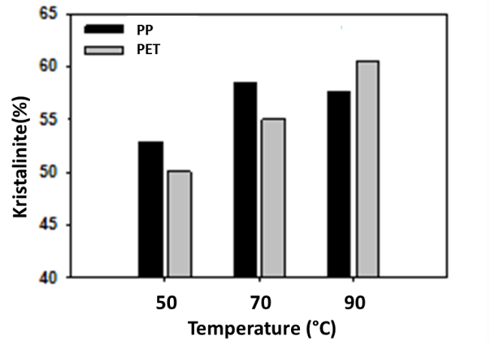
Figure 1. Comparison of the crystallinity of PP and PET fibres
CONCLUSIONS
Times new roman 10
250-500 characters

SUGGESTIONF FOR FURTHER WORK
Times new roman 10
Max. 250 characters

ACKNOWLEDGEMENTS/SOURCES OF FUNDING
Times new roman 10
250 characters

LITERATURE
- In alphabetical order according to the Author surname.
- Periodicals:

Author Surname, Initians of the Author. Year. “Title of the paper”, Journal Name, Vol (No), page Numbers.

Eg:
Çelik, E. J. 1986. “Crystallinity of PET fibers”, Textile Research Journal, 104, 269-274.
- Book:

Author Surname, Initians of the Author. Year. Book Title. Place of Publication: Publisher.

Eg:

Kılıç, S. 2008. Crystallinity of PET fibers. Ankara: TÜBİTAK Yayınları.
- Materials from Internet web pages:

“Title”. Name of the internet web pages. Internet web address, Latest Access date: Day month Year.
Eg:
“Crystallinity of PET fibers”. LPAE Dergisi.
http://www.lpae.com/news/2012/10/physi
Latest Access date: 15 December 2018.

